**AHA DIY GARAGE WEB PAGE**

It will have:

* Form for the user to insert information to the database.
* Table with selectable hours, and the hours that aren’t selectable will appear with another color.
* Menu on the top side of the web page with the options: Home, About us, contact, Log in.
* Footer on the bottom side with information about the location, contact number, email…
* The home page will have a small introduction followed with a button to rent a garage.
* The About us page will have an image with some text explaining how the garage works.
* The contact page will have information to contact us.
* The login and signup page will let the user create an account and log in to the account.

Home page:

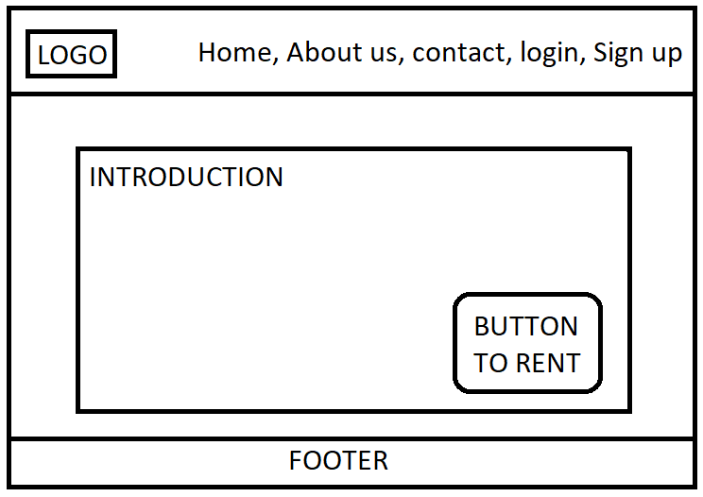

* The logo, if clicked, will take the user to the home page.
* There will be a small introduction with images.
* The rent button will send the user to the rent page, but if the user didn’t login, it will take the user to the login / signup page.
* The footer contains some basic contact information.

Contact:

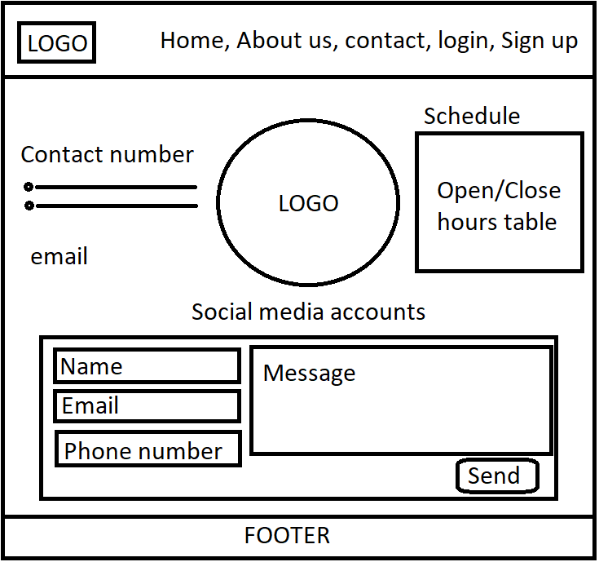

* This page will contain enough information for the user to contact us, and a form to send any message the user wants directly to us.

About us:

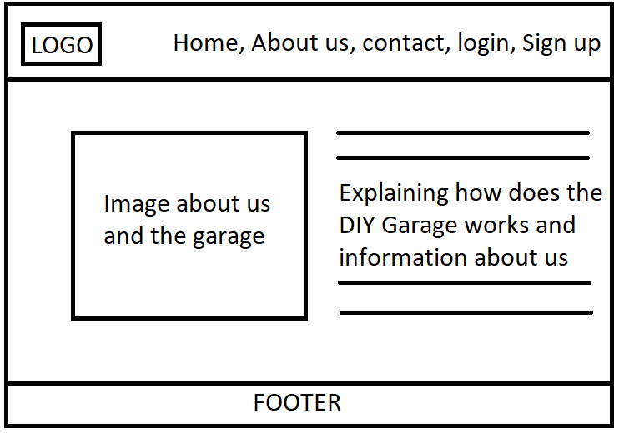

* This page contains information about us and how does the DIY Garage work

Log in / Sign up page:

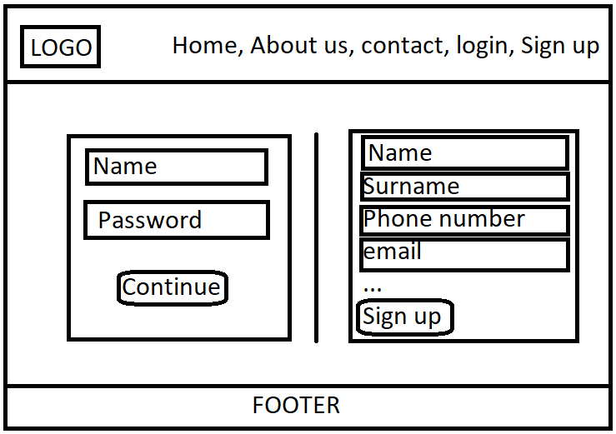

* The left form is for the user to log in.
* The right form is for the user to create a new account.

Web site the user after the user log in:

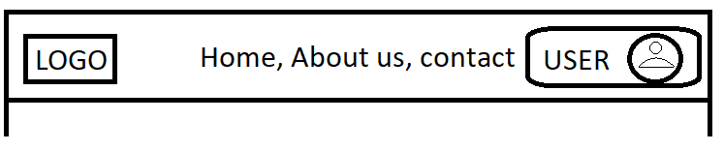

* The user name and icon will appear in the header

On click, a menu will be displayed, with the Log out option.

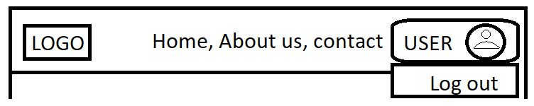

Rent page:

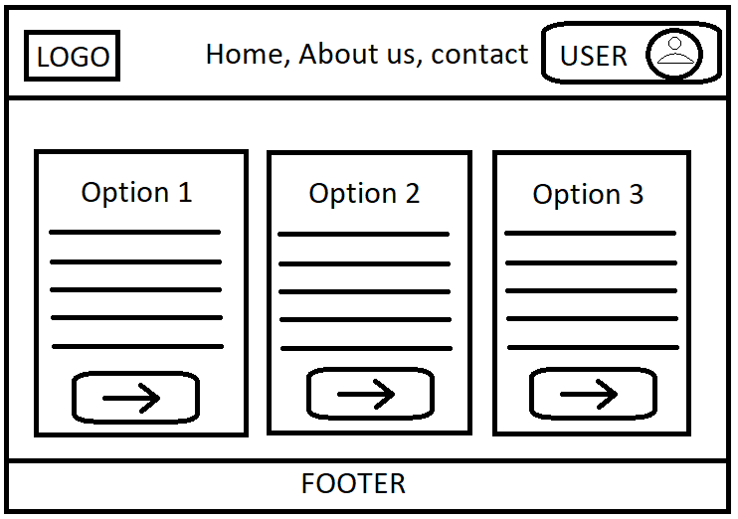

* There will be three options to choose depending on the user needs.
* Every option has their unique table with hours.

Hours table and products page:

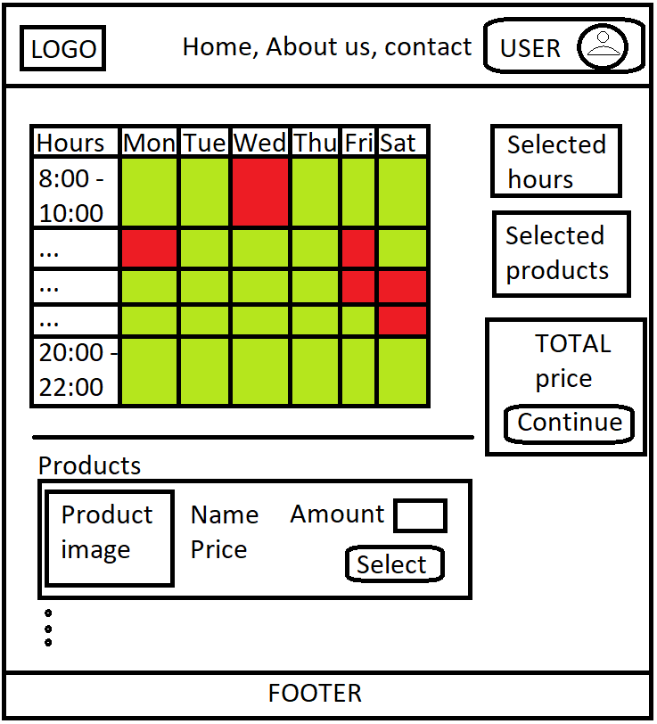

* The user can choose the needed hours, the available hours will appear in green, and the not available hours will appear red.
* Below the hours table, there will be a product list. The user can select any product and the quantity they want, and after clicking the select button the product will be added.
* There will be 3 containers on the right side of the page. The first container will display the selected hours, the second container will display the selected products, and the third container will show the total price of both selected products and the choosed hours. Also, this container will have a “continue” button to confirm all.